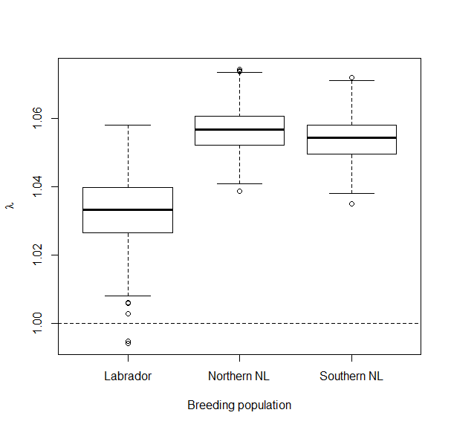

Good breeding conditions (RS = 0.643)

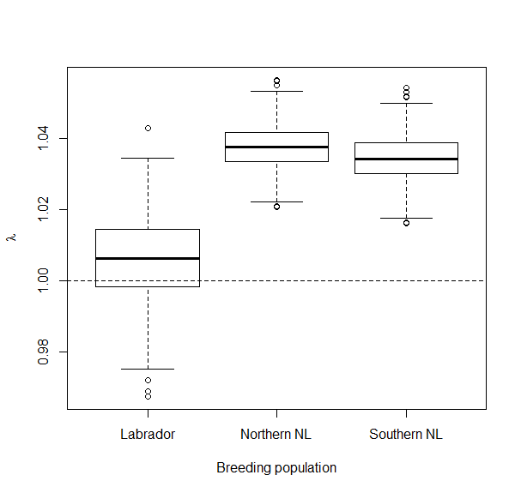

Fair breeding conditions (RS = 0.482)

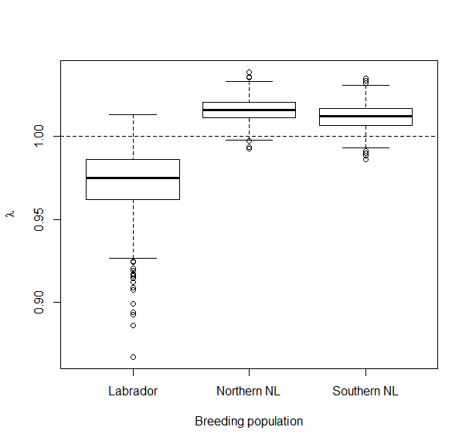

Poor breeding conditions (RS=0.321)